cycle6

Experiment 1

aim

source code
class BankAccount:
def __init__(self, name, account_number, account_type, balance):
self.name = name
self.account_number = account_number
self.account_type = account_type
self.balance = balance

def deposit(self, amount):
"""Method to deposit an amount into the account."""
if amount > 0:
self.balance += amount
print(f"Deposited {amount}. New balance is {self.balance}.")
else:
print("Deposit amount must be positive.")

def withdraw(self, amount):
"""Method to withdraw an amount from the account."""
if amount <= 0:
print("Withdrawal amount must be positive.")
elif amount > self.balance:
print("Insufficient balance.")
else:
self.balance -= amount
print(f"Withdrew {amount}. New balance is {self.balance}.")

def display_details(self):
"""Method to display account details."""
print(f"\nAccount Holder: {self.name}")
print(f"Account Number: {self.account_number}")
print(f"Account Type: {self.account_type}")
print(f"Balance: {self.balance}")

# Main program
print("Enter account details to create a new account:")
name = input("Enter account holder name: ")
account_number = input("Enter account number: ")
account_type = input("Enter account type (e.g., Savings, Current): ")
balance = float(input("Enter initial balance: "))

# Create an account
account1 = BankAccount(name, account_number, account_type, balance)
account1.display_details()

while True:
print("\nChoose an operation:")
print("1. Deposit")
print("2. Withdraw")
print("3. Display Account Details")
print("4. Exit")
choice = input("Enter your choice (1/2/3/4): ")

if choice == "1":
deposit_amount = float(input("Enter deposit amount: "))
account1.deposit(deposit_amount)
elif choice == "2":
withdraw_amount = float(input("Enter withdrawal amount: "))
account1.withdraw(withdraw_amount)
elif choice == "3":
account1.display_details()
elif choice == "4":
print("Exiting the program.")
break
else:
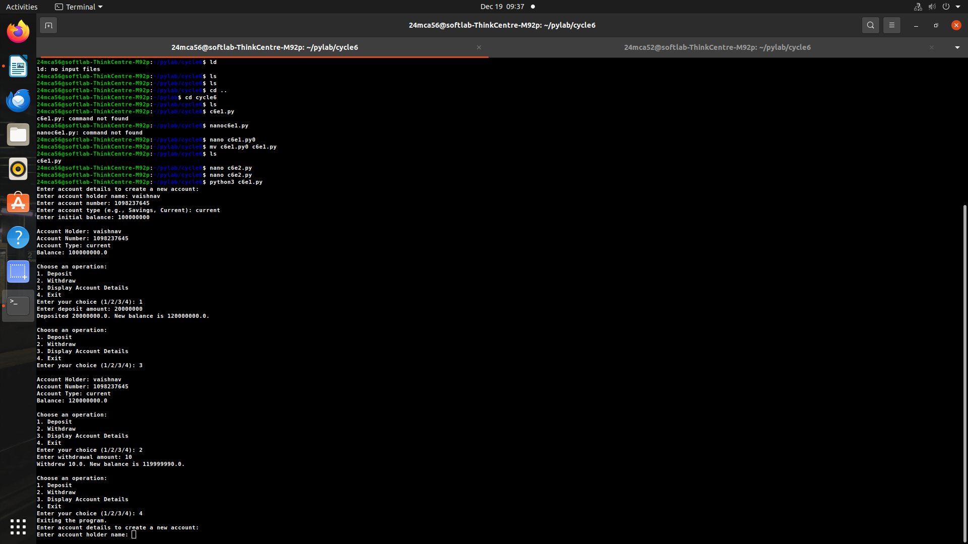
print("Invalid choice. Please try again.")

Experiment 2

aim

source code
class Publisher:

def __init__(self, publisher_id, publisher_name):
self.publisher_id = publisher_id
self.publisher_name = publisher_name

def display_publisher(self):
print(f"Publisher ID: {self.publisher_id}")
print(f"Publisher Name: {self.publisher_name}")

class Book(Publisher):
def __init__(self, publisher_id, publisher_name, title, author):
super().__init__(publisher_id, publisher_name)
self.title = title
self.author = author

def display_book(self):
print(f"Title: {self.title}")
print(f"Author: {self.author}")

class Python(Book):
def __init__(self, publisher_id, publisher_name, title, author, price, no_of_pages):
super().__init__(publisher_id, publisher_name, title, author)
self.price = price
self.no_of_pages = no_of_pages

def display_python_book(self):
print(f"Price: {self.price}")
print(f"Number of Pages: {self.no_of_pages}")

if __name__ == "__main__":
publisher_id = input("Enter Publisher ID: ")
publisher_name = input("Enter Publisher Name: ")
title = input("Enter Book Title: ")
author = input("Enter Author Name: ")
price = float(input("Enter Book Price: "))
no_of_pages = int(input("Enter Number of Pages: "))

print()
python_book = Python(publisher_id, publisher_name, title, author, price, no_of_pages)
python_book.display_publisher()
python_book.display_book()
python_book.display_python_book()

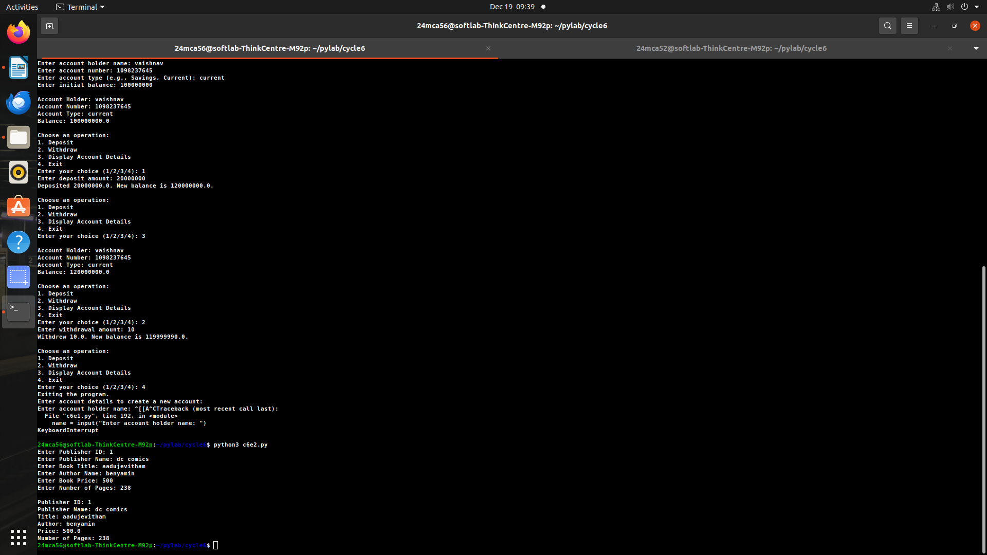

Experiment 3

aim

source code

from abc import ABC, abstractmethod

class Polygon(ABC):
@abstractmethod
def get_dimensions(self):
pass

@abstractmethod
def calculate_area(self):
pass

class Rectangle(Polygon):
def __init__(self):
self.length = 0
self.width = 0

def get_dimensions(self):
self.length = float(input("Enter the length of the rectangle: "))
self.width = float(input("Enter the width of the rectangle: "))

def calculate_area(self):
area = self.length * self.width
return area

class Triangle(Polygon):
def __init__(self):
self.base = 0
self.height = 0

def get_dimensions(self):
self.base = float(input("Enter the base of the triangle: "))
self.height = float(input("Enter the height of the triangle: "))

def calculate_area(self):
area = 0.5 * self.base * self.height
return area

if __name__ == "__main__":
print("Choose a polygon to calculate area:")
print("1. Rectangle")
print("2. Triangle")
choice = input("Enter your choice (1/2): ")

if choice == "1":
rectangle = Rectangle()
rectangle.get_dimensions()
area = rectangle.calculate_area()
print(f"The area of the rectangle is: {area}")
elif choice == "2":
triangle = Triangle()
triangle.get_dimensions()
area = triangle.calculate_area()
print(f"The area of the triangle is: {area}")
else:
print("Invalid choice. Please select either 1 or 2.")
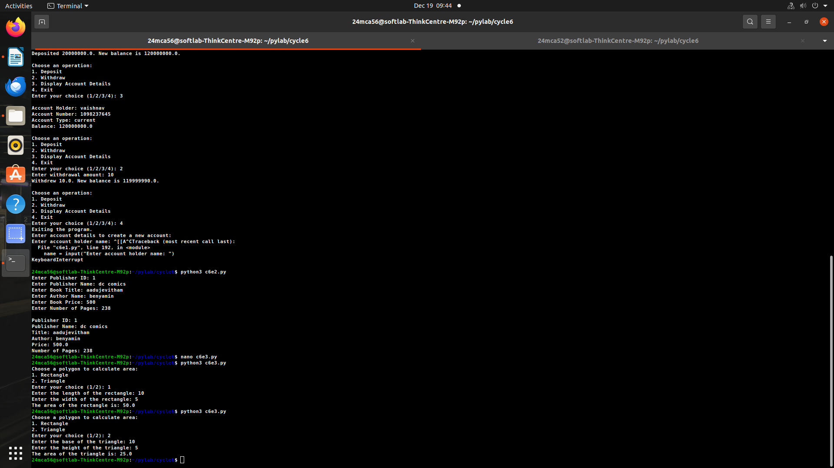

Experiment 4

aim

source code
class Rectangle:
def __init__(self, length, breadth):
self.length = length
self.breadth = breadth

def area(self):
"""Method to calculate the area of the rectangle."""
return self.length * self.breadth

def perimeter(self):
"""Method to calculate the perimeter of the rectangle."""
return 2 * (self.length + self.breadth)

if __name__ == "__main__":
print("Enter the dimensions for Rectangle 1:")
length1 = float(input("Enter the length of the rectangle: "))
breadth1 = float(input("Enter the breadth of the rectangle: "))
rect1 = Rectangle(length1, breadth1)

print("\nEnter the dimensions for Rectangle 2:")
length2 = float(input("Enter the length of the rectangle: "))
breadth2 = float(input("Enter the breadth of the rectangle: "))
rect2 = Rectangle(length2, breadth2)

print(f"\nRectangle 1 - Area: {rect1.area()} | Perimeter: {rect1.perimeter()}")
print(f"Rectangle 2 - Area: {rect2.area()} | Perimeter: {rect2.perimeter()}")

area1 = rect1.area()
area2 = rect2.area()

if area1 < area2:
print("\nRectangle 1 has a smaller area than Rectangle 2.")
elif area1 == area2:
print("\nRectangle 1 and Rectangle 2 have the same area.")
else:
print("\nRectangle 1 has a larger area than Rectangle 2.")

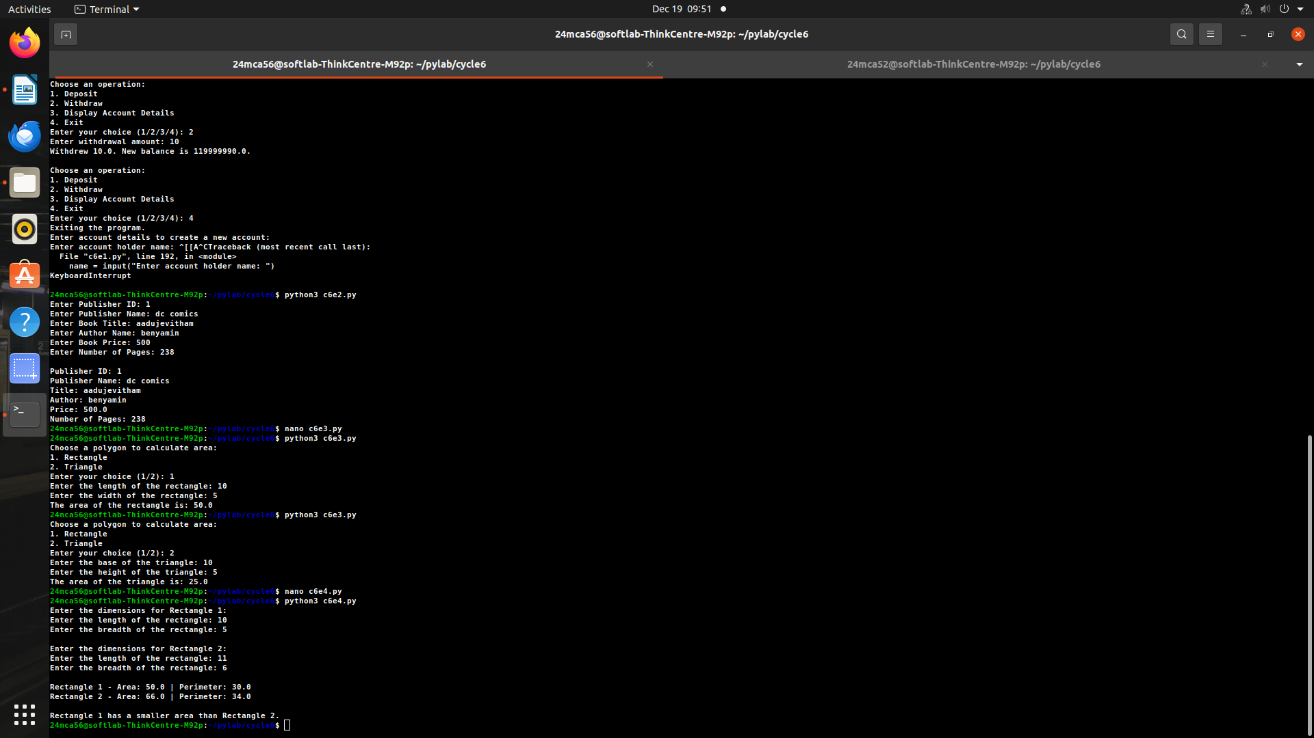
Experiment 5

aim

source code

class Time:
def __init__(self, hour=0, minute=0, second=0):
self.__hour = hour
self.__minute = minute
self.__second = second

def _normalize(self):
"""Normalize the time so that seconds and minutes are within their valid ranges."""
if self.__second >= 60:
self.__minute += self.__second // 60
self.__second = self.__second % 60
if self.__minute >= 60:
self.__hour += self.__minute // 60
self.__minute = self.__minute % 60
if self.__hour >= 24:
self.__hour = self.__hour % 24

def __add__(self, other):
"""Add two Time objects and return a new Time object."""
if not isinstance(other, Time):
raise TypeError("Operand must be of type 'Time'")
total_hour = self.__hour + other.__hour
total_minute = self.__minute + other.__minute
total_second = self.__second + other.__second
result = Time(total_hour, total_minute, total_second)
result._normalize()
return result

def __str__(self):
"""Return the time in HH:MM:SS format."""
return f"{self.__hour:02d}:{self.__minute:02d}:{self.__second:02d}"

def get_time_from_user():
"""Get valid time input from the user."""
while True:
try:
hour = int(input("Enter hours (0-23): "))
minute = int(input("Enter minutes (0-59): "))
second = int(input("Enter seconds (0-59): "))
if not (0 <= hour <= 23) or not (0 <= minute <= 59) or not (0 <= second <= 59):
print("Invalid time input. Please enter valid values for hour, minute, and second.")
continue
return Time(hour, minute, second)
except ValueError:
print("Invalid input. Please enter integers for hours, minutes, and seconds.")

if __name__ == "__main__":
print("Enter details for Time 1:")
time1 = get_time_from_user()

print("\nEnter details for Time 2:")
time2 = get_time_from_user()

print("\nTime 1:", time1)
print("Time 2:", time2)

time_sum = time1 + time2
print("Sum of Time 1 and Time 2:", time_sum)

